**Yorkshire Veterans’ Athletics Association**

[](http://www.englandathletics.org/welcome)

From:

Rob Kersey

T.01484 685789

Email: [robhh1950@gmail.com](mailto:robhh1950@gmail.com)

YVAA website: [www.yvaa.org](http://www.yvaa.org)

**YVAA 43rd Cross Country Championships**

**Saturday 12th March 2022**

**Venue:** Norfolk Heritage Park, Sheffield, S2 2PL

Hosted by Steel City Striders (Permit applied for)

**Directions From M1:** Take exit J33 Rotherham / Sheffield Parkway / A630. Continue on A630 till the exit towards Attercliffe / Manor Park. Turn left onto Manor Lane, then right staying on Manor Lane.

Turn left where Manor Lane becomes St Aidan’s Road. Turn right onto Guildford Road.

Postcode for Satnav is **S2 2PL**.

**Getting into the park**

There are a number of entrances to Norfolk Heritage Park, the main ones being off: Granville Road, Norfolk Park Road and Guildford Avenue.

**Parking:** Parking at the car park off Guildford Avenue is limited to 20 cars and will only be open to race officials and YVAA officials. There is ample street parking around the park. If using nearby streets please park sensibly taking care not to restrict resident’s access.

Please car share wherever possible.

**Coaches:** If you are bringing a coach it would help to inform the organiser before the event, so he can advise you on the best place to park.

**Registration:** Registration will take place at the Community Centre in the park. Team managers or a representative from each club should collect envelopes containing numbers and age group categories (to be worn on the back). Registration will open at approx. 10.30 am. Please make sure your athletes bring enough pins for both race number and age category number. Bring your own sandwiches and light refreshments. Access to the course is from the main car park.

**Facilities:** Toilets are available at the Community Centre in the park. Please remove muddy shoes before entering.

**Presentations:** The presentations will take place in Community Centre after the finish of the last race, as soon as they have been processed. Please ensure you or another member of your club stays to collect any trophies, individual or team that may have been won. Obviously, all data has to be entered, results checked and printed, this will be done as fast as it is humanly possible but will not be instant! Bring some sandwiches and light refreshments and chat to your fellow competitors about the great or not so great run you’ve just had! There is a café in the park.

**The Course:** The course below will be used.

**Club Tents:** An area for club tents is available next to the start and finish areas between A, L and M on map.

**Course and General View of the Area**

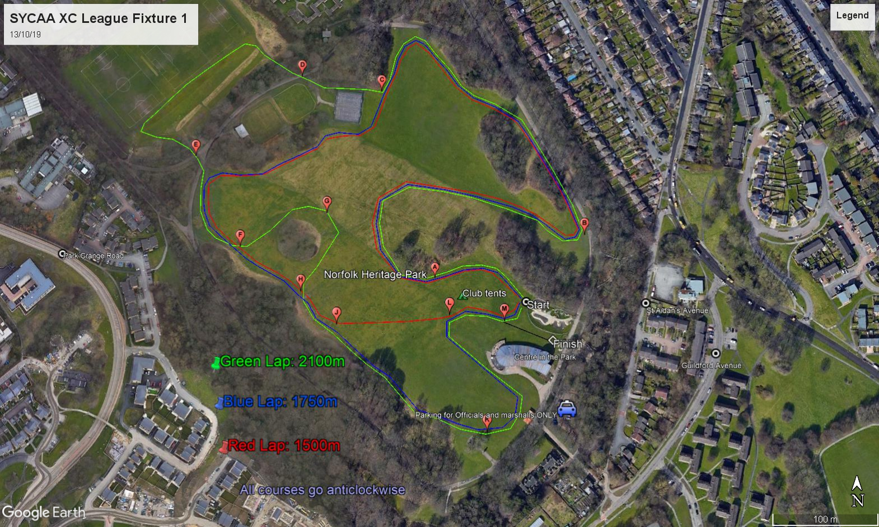

**Race 1) Start at 12.00 noon: (All F45+, F55+ and F65+ ladies and M70+) 5K – 2 blue laps and 1 red lap.**

Start (2x) A-B-C-F-H-J-K-L-M- Then A-B-C-F-H-J-L-M-Finish

**Race 2) Start at 1.20 pm: (M50, M55, M60 and M65 and F35 - 44) 9.9K – 4 green laps and 1 red.**

Start (4x) A-B-C-D-E-F-G-H-J-K-L-M- Then A-B-C-F-H-J-L-M-Finish

**Race 3) Start at 1.20 pm approx.: (M35, M40 and M45) 9.9K – 4 green laps and 1 red.**

Start (4x) A-B-C-D-E-F-G-H-J-K-L-M- Then A-B-C-F-H-J-L-M-Finish

**Notes:**

1. **Teams are M35 – 39, M40 – 49, M50 – 59, M60 – 69, M70+, F35 – 44, F45 – 54, F55 – 64 and F65+ but individual trophies are in usual 5-year age groups.**
2. **An older runner can compete in a younger team e.g.** **F45 in F35 - 44 team but can only count towards individual trophy if in correct race e.g. F45 in F35 - 44 team would run in Race 2 whereas all other F45’s in Race 1, so couldn’t count in individual F45.**

**YVAA Awards**

**Men** 1st 3 M/35, M/40, M/45, M/50, M/55, M/60, M/65, M/70, M75+

**Women** 1st 3 F35, F/40, F/45, F/50, F/55, F/60, F/65, F/70+

**Teams:** 3 to score; Men 35 -39, 40 – 49, 50 – 59, 60 - 69, 70 +

Women 35 – 44, 45 – 54, 55- 64 and 65+ (medals for 1st, 2nd and 3rd teams)

**Also Shields for ‘All to Count’ teams in each team age category. A minimum of 5 runners needed to qualify in all teams. Winning team (1st 3 to count) are eligible to win All to Count if they have sufficient entries to qualify.**

**Numbers/Registration (from 10.30 am):** To be collected on the day by team managers. Please ensure your runners bring a minimum of 6 pins for numbers/age categories.

**NOTE: All runners must wear club vests with age category on the back of their vest. Failure to do so may result in demotion down finish list if a complaint is made to the referee and it is deemed to have a possible effect on placings.**

**Entry Fee:** £6.00 per individual runner. Cheques payable to Yorkshire Veterans Athletics Association (in full not YVAA). Contact the YVAA treasurer by email Thomas Sharp [thomas.sharp@me.com](mailto:thomas.sharp@me.com) if you wish to pay by bank transfer.

**Entries to:** Rob Kersey, 8 Wellhouses, Cartworth Bank Road, Holmfirth, W Yorks. HD9 2SS, on official entry form (on website at [www.yvaa.org](http://www.yvaa.org) and sent to all clubs by email. Please enclose sae if you wish for confirmation that your entries have been received otherwise I will try and send email confirmation if you supply **readable** email address!

**Closing Date:** Saturday 5th March 2022.

**NOTE:** While we will try to be as flexible as possible with late entries we cannot guarantee entries after the closing date. Clubs must ring or email Rob Kersey, [robhh1950@gmail.com](mailto:robhh1950@gmail.com), to check it is possible and if agreed ok, must bring a cheque or cash (**in an envelope**) on the day if it cannot reach him in time by post.