Ackworth Almost Actual Half Marathon

Recommended Course 2020

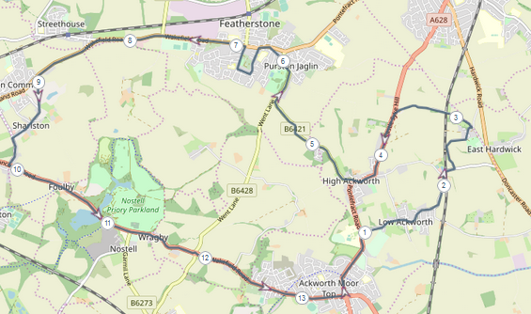
Mile markers assume a start opposite the Boot & Shoe, Wakefield Road, Ackworth.

Course Directions
- Assuming start in Ackworth. You can start at any convenient point on the route – just finish where you started!
Start to Mile 1: starting at the junction of Wakefield Road and Bell Lane (opposite the Boot & Shoe pub) – run towards the roundabout (Beverley Arms / Ego) and turn left towards Pontefract. You will need to cross over to the opposite side of the road using one of the pelican crossings or one of the traffic islands as you go down the hill. Please take care as the road can be busy. Run past Carr Bridge playing fields towards the Quaker School.
Mile 1-2: Turn right down Station Road (opposite the Quaker School) towards Low Ackworth. Bear left where the road splits by the grassed triangle to follow Station Road towards the Rustic Arms.
Mile 2-3: Keep on Station Road to cross over the railway bridge. There is a short section where there is no footpath – please keep to the left. After a short distance turn left into Hundhill Lane. This is a narrow road with no footpath. Although quiet you can expect to meet the odd vehicle. Follow the road as it winds through Hundhill until reaching the crossroads. Turn Left into Sandygate Lane.
Mile 3-4: Run up Sandygate Lane until it reaches Pontefract Road with the Water Tower on your left. This again is a narrow road and although quiet, you can expect to meet one of more vehicles. On reaching Pontefract Road cross over with care – this is a busy road. Turn left to run downhill towards High Ackworth.
Mile 4-5: Follow the road then immediately after the Brown Cow pub bear right onto Purston Lane (Church on your right).
Mile 5-6: Follow the road to Purston – crossing over the road at a safe point by the park.
Mile 6-7: Shortly after passing the park, turn left onto the one way street (Ackworth Road), then left at the traffic lights on Wakefield Road. Take the 2nd left into Nunns Lane. Follow the road until it bends to the right to become Gurnhill Lane. Turn right again to follow Gurnhill Lane back towards the traffic lights at Wakefield Road, Cross safely to the footpath at the other side of the road before reaching the traffic lights. Turn left onto Wakefield Road.
Mile 7-8: Keep on Wakefield Road to ‘Victoria’ garden centre – cross over to the other footpath at a safe point – this is a busy road.
Mile 8-9: Keep on Wakefield Road which becomes Weeland Road to reach Sharlston. Turn left into The Green at Sharlston Common.
Mile 9-10: Follow the road ahead until reaching the White Horse pub (on your right). Turn left at the junction with West Lane. Turn left when reaching Doncaster Road (towards Nostell).
Mile 10-11: Continue on Doncaster towards Nostell Priory. Take care when crossing the lake bridge if running with others as the footpath is narrow.
Mile 11-12: Keep on Doncaster Road – again taking care on the narrow footpath through Wragby. On reaching the roundabout,go straight ahead towards Ackworth. Take care when crossing the road.
Mile 12-13: Keep on the main road into Ackworth until reaching the start point.

